Departmental Database

Part B: Relational Database Implementation

[Name]

[Student Id]

**Document Name**: DatabaseTemplatePartB.docx

Document History

|  |  |  |  |  |  |
| --- | --- | --- | --- | --- | --- |
| Date | Version | Revision | Description | Author | Role |
| 31/08/2022 | 1 | 1 | First version document |  | System Analyst |
|  |  |  |  |  |  |
|  |  |  |  |  |  |
|  |  |  |  |  |  |
|  |  |  |  |  |  |
|  |  |  |  |  |  |

**Table of Contents**

1. Revised Scope and Boundaries 3

2. Revised Business Rules 3

3. Final Entity Relationship Diagram 3

4. SQL to Create Database and Tables 3

5. SQL Queries 0

6. Views 0

6.1. Creating View 0

6.2. Running view 0

6.3. Dropping View 0

7. Stored Procedures 0

7.1. Retrieving Data Using a Stored Procedure 0

7.2. Inserting Data Using a Stored Procedure 0

7.3. Modifying Data Using a Stored Procedure 0

7.4. Stored Procedure Using a Parameter 0

7.5. Dropping a Stored Procedure 0

8. Triggers 0

8.1. Trigger 1 0

8.2. Trigger 2 0

9. Appendix 1

# Revised Scope and Boundaries

# Revised Business Rules

# Final Entity Relationship Diagram

# SQL to Create Database and Tables

**SELECT * FROM mydb_UPDATE.CLASS;**

INSERT INTO mydb_UPDATE.CLASS(CLASS_ID, TEACHER_ID, SUBJECT_ID, START_TIME, STUDENT_ID, NUMBER_OF_STUDENTS, CLASS_NAME)

VALUES (1, 1, 2,'Wed 9am', 3, 2, 'COMPUTER SCIENCE');

INSERT INTO mydb_UPDATE.CLASS(CLASS_ID, TEACHER_ID, SUBJECT_ID, START_TIME, STUDENT_ID, NUMBER_OF_STUDENTS, CLASS_NAME)

VALUES (2, 3, 2,'Tues 11am', 2, 3, 'PYTHON LANGUAGE');

INSERT INTO mydb_UPDATE.CLASS(CLASS_ID, TEACHER_ID, SUBJECT_ID, START_TIME, STUDENT_ID, NUMBER_OF_STUDENTS, CLASS_NAME)

VALUES (3, 2, 1,'Fri 9am', 1, 3, 'COMMERCIAL LAW');

**SELECT * FROM mydb_UPDATE.DEPARTMENT;**

INSERT INTO mydb_UPDATE.DEPARTMENT (DEPARTMENT_NAME, DEPARTMENT_ID)

VALUES ('BUSINESS DEPARTMENT', 1);

INSERT INTO mydb_UPDATE.DEPARTMENT (DEPARTMENT_NAME, DEPARTMENT_ID)

VALUES ('COMPUTER SCIENCE DEPARTMENT', 2);

INSERT INTO mydb_UPDATE.DEPARTMENT (DEPARTMENT_NAME, DEPARTMENT_ID)

VALUES ('COMMERCE DEPARTMENT',3);

**SELECT * FROM mydb_UPDATE.COURSE;**

INSERT INTO mydb_UPDATE.COURSE (COURSE_ID, DEPARTMENT_ID, COURSE_NAME)

VALUES (1, 2,'ICT40220') ;

INSERT INTO mydb_UPDATE.COURSE (COURSE_ID,DEPARTMENT_ID, COURSE_NAME)

VALUES(2, 2,'ICT30220');

INSERT INTO mydb_UPDATE.COURSE (COURSE_ID,DEPARTMENT_ID, COURSE_NAME)

VALUES (3, 2, 'ICT50220');

**SELECT * FROM mydb_UPDATE.PERSON;**

INSERT INTO mydb_UPDATE.PERSON(PERSON_ID,FIRST_NAME, LAST_NAME, EMAIL, MOBILE, AGE, DOB)

VALUES(1,'ALICE', 'ROBERSTON', 'ROBERTSON.ALICE@HOTMAIL.COM' , 470894685, 34, '1988-09-02');

INSERT INTO mydb_UPDATE.PERSON(PERSON_ID,FIRST_NAME, LAST_NAME, EMAIL, MOBILE, AGE, DOB)

VALUES(2, 'BOB', 'JOHNSON', 'JOHNSON.BOB@HOTMAIL.COM', 403598764, 26, '1996-03-15');

INSERT INTO mydb_UPDATE.PERSON(PERSON_ID,FIRST_NAME, LAST_NAME, EMAIL, MOBILE, AGE, DOB)

VALUES(3,'CHRIS', 'WONG', 'WONG.CHRIS@HOTMAIL.COM', 428976874, 18, '2004-08-12' );

INSERT INTO mydb_UPDATE.PERSON(PERSON_ID,FIRST_NAME, LAST_NAME, EMAIL, MOBILE,AGE, DOB)

VALUES(4,'DAVE', 'CHARMCHY', 'CHARMCHY.DAVE@HOTMAIL.COM', 412937952, 45, '1977-03-17' );

INSERT INTO mydb_UPDATE.PERSON(PERSON_ID,FIRST_NAME, LAST_NAME, EMAIL, MOBILE, AGE, DOB)

VALUES(5,'EVE', 'MORRISON', 'EVE.MORRISON@HOTMAIL.COM', 412937952,23, '1999-05-16' );

INSERT INTO mydb_UPDATE.PERSON(PERSON_ID,FIRST_NAME, LAST_NAME, EMAIL, MOBILE, AGE, DOB)

VALUES(6,'COCO', 'WILLAM', 'COCO.WILLAM@HOTMAIL.COM', 412937952, 34, '1988-06-07');

**SELECT * FROM mydb_UPDATE.TEACHERS;**

INSERT INTO mydb_UPDATE.TEACHERS(FIRST_NAME, LAST_NAME, TEACHER_EMAIL, TEACHER_ID, PAY_CODE)

VALUES('DAVE', 'CHARMCHY', 'CHARMCHY.DAVE@HOTMAIL.COM',1,'3.1' );

INSERT INTO mydb_UPDATE.TEACHERS(FIRST_NAME, LAST_NAME, TEACHER_EMAIL, TEACHER_ID, PAY_CODE)

VALUES('EVE', 'MORRISON', 'EVE.MORRISON@HOTMAIL.COM', 2,'3.2');

INSERT INTO mydb_UPDATE.TEACHERS(FIRST_NAME, LAST_NAME, TEACHER_EMAIL, TEACHER_ID, PAY_CODE)

VALUES('COCO', 'WILLAM', 'COCO.WILLAM@HOTMAIL.COM', 3,'3.3');

**SELECT * FROM mydb_UPDATE.SUBJECTS;**

INSERT INTO mydb_UPDATE.SUBJECTS (SUBJECT_ID, SUBJECT_NAME, COURSE_ID, AVERAGE_SCORE)

VALUES (1,'DIGITAL IMAGES', 1, 78);

INSERT INTO mydb_UPDATE.SUBJECTS (SUBJECT_ID, SUBJECT_NAME, COURSE_ID, AVERAGE_SCORE)

VALUES (2,'WEB DEV', 2, 80);

INSERT INTO mydb_UPDATE.SUBJECTS (SUBJECT_ID, SUBJECT_NAME, COURSE_ID, AVERAGE_SCORE)

VALUES (3,'DATABASE', 2, 82);

# SQL Queries

|  |  |  |
| --- | --- | --- |
| **Purpose** | **Tables Involved** | **Command(s) Involved and**  **Result** |
| *A:,List all students in alphabetical order* | *Students* | *SELECT * FROM mydb_UPDATE.STUDENTS;*  *SELECT STUDENT_ID, FIRST_NAME, LAST_NAME*  *FROM STUDENTS*  *ORDER BY FIRST_NAME ASC;* |
| B:Retrieve student age records | Students, person | *LECT AGE, S. FIRST_NAME, S. LAST_NAME, S. STUDENT_EMAIL,S.STUDENT_NUMBER*  *FROM mydb_UPDATE.STUDENTS S*  *JOIN mydb_UPDATE.PERSON P*  *ON S.FIRST_NAME = P.FIRST_NAME AND S.LAST_NAME = P.LAST_NAME;* |
| C: the number of persons | person | SELECT COUNT(PERSON_ID)  FROM mydb_UPDATE.PERSON; |
| D:student_id, who select which couse | Class, subject | SELECT C.CLASS_ID, S.AVERAGE_SCORE  FROM mydb_UPDATE.CLASS C, mydb_UPDATE.SUBJECTS S  WHERE C.SUBJECT_ID = S.SUBJECT_ID  AND S.AVERAGE_SCORE > 79; |
| E:the class whose subject average score is higher than 20 | course and subject | SELECT * FROM COURSE  WHERE COURSE_ID IN  (SELECT COURSE_ID FROM SUBJECTS where AVERAGE_SCORE>80) |
| F:square root (average_score )*10 | Subjects | SELECT (SQRT(AVERAGE_SCORE)* 10) FROM mydb_UPDATE.SUBJECTS; |
| G:DOB is greater than 1990-0101 |  | SELECT * FROM mydb_UPDATE.PERSON  WHERE DOB > '1990-01-01'  ORDER BY DOB DESC |

# Views

## Creating View, Running view, Dropping View

## 

CREATE VIEW mydb.SCORE_GT_82 AS

SELECT C.CLASS_ID, S.AVERAGE_SCORE

FROM mydb.CLASS C, mydb.SUBJECTS S

WHERE C.SUBJECT_ID = S.SUBJECT_ID

AND S.AVERAGE_SCORE >= 82;

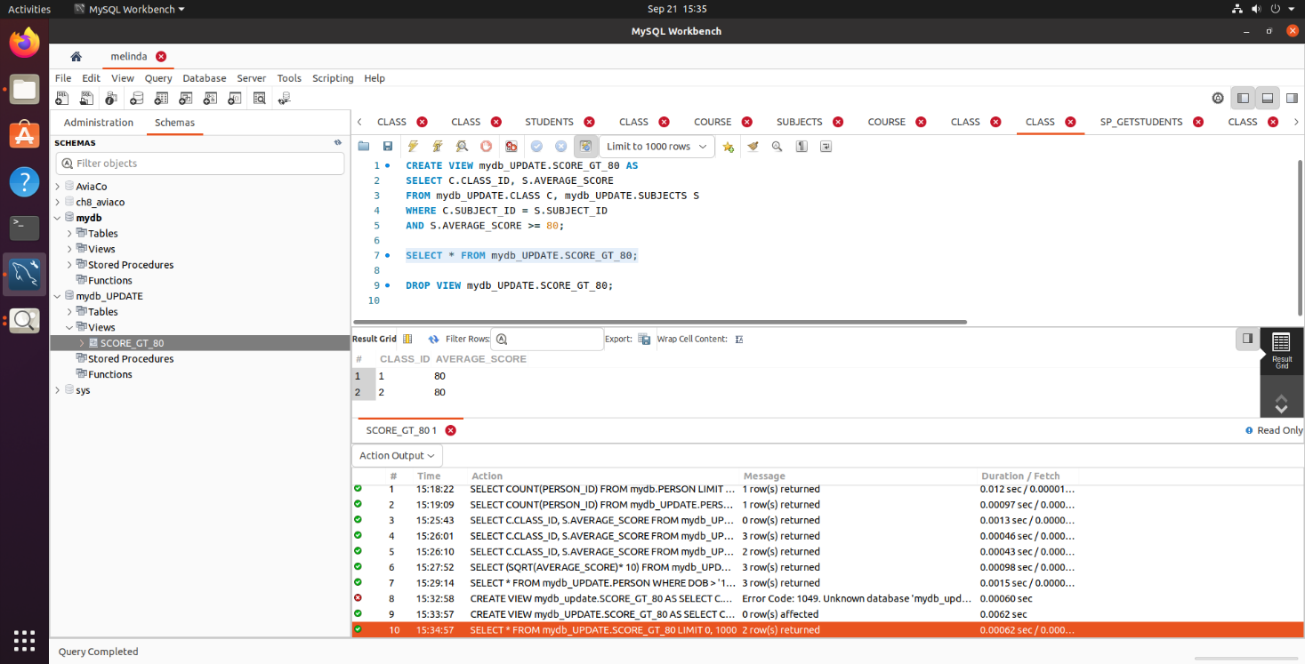

SELECT * FROM mydb.SCORE_GT_82;

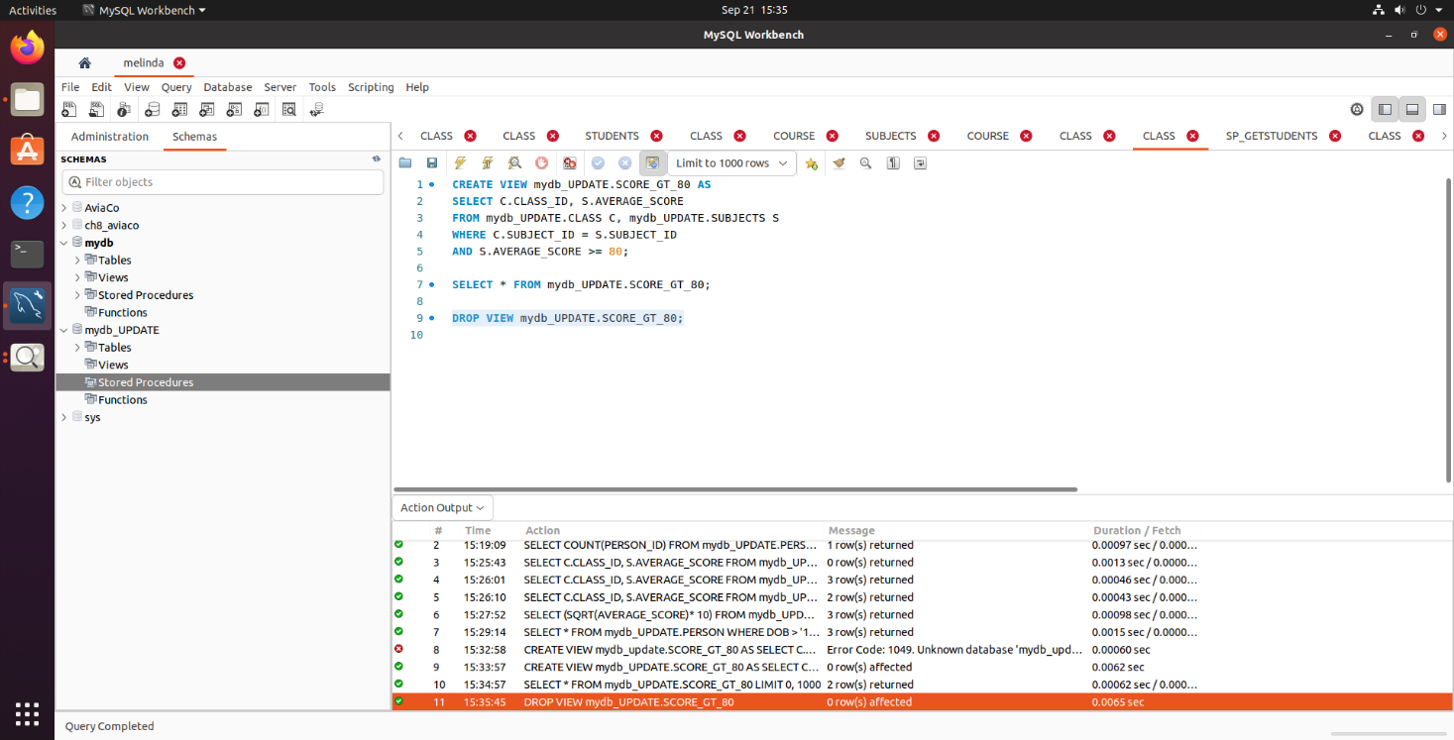DROP VIEW mydb.SCORE_GT_82;

# Stored Procedures

## Retrieving Data Using a Stored Procedure

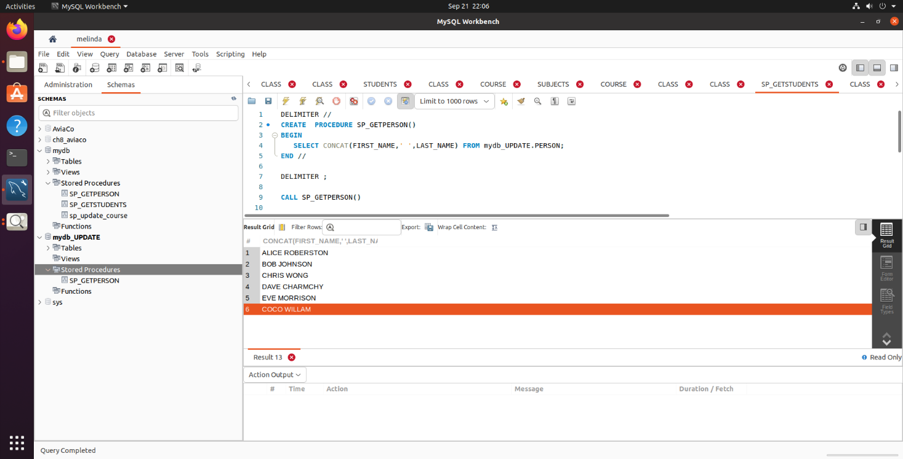

DELIMITER //

CREATE PROCEDURE SP_GETPERSON()

BEGIN

SELECT CONCAT(FIRST_NAME,' ',LAST_NAME) FROM mydb_UPDATE.PERSON;

END //

DELIMITER ;

CALL SP_GETPERSON()

## Inserting Data Using a Stored Procedure

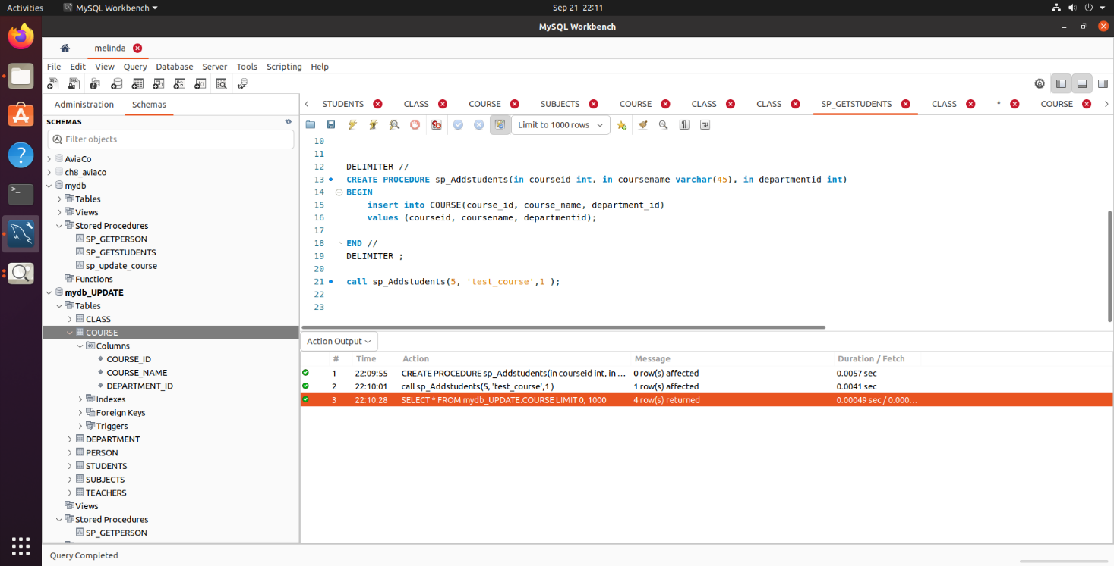

DELIMITER //

CREATE PROCEDURE sp_Addstudents(in courseid int, in coursename varchar(45), in departmentid int)

BEGIN

insert into COURSE(course_id, course_name, department_id)

values (courseid, coursename, departmentid);

END //

DELIMITER ;

call sp_Addstudents(5, 'test_course',1 );

## Modifying Data Using a Stored Procedure

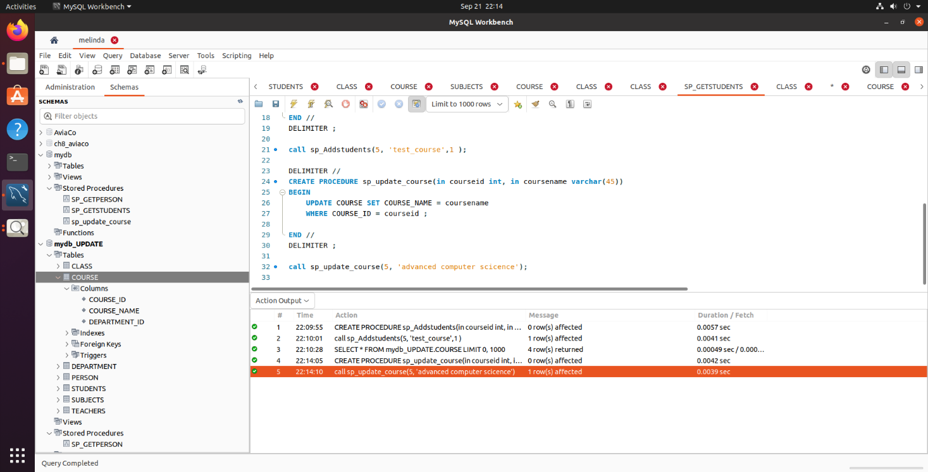

DELIMITER //

CREATE PROCEDURE sp_update_course(in courseid int, in coursename varchar(45))

BEGIN

UPDATE COURSE SET COURSE_NAME = coursename

WHERE COURSE_ID = courseid ;

END //

DELIMITER ;

call sp_update_course(5, 'advanced computer scicence');

## Stored Procedure Using a Parameter

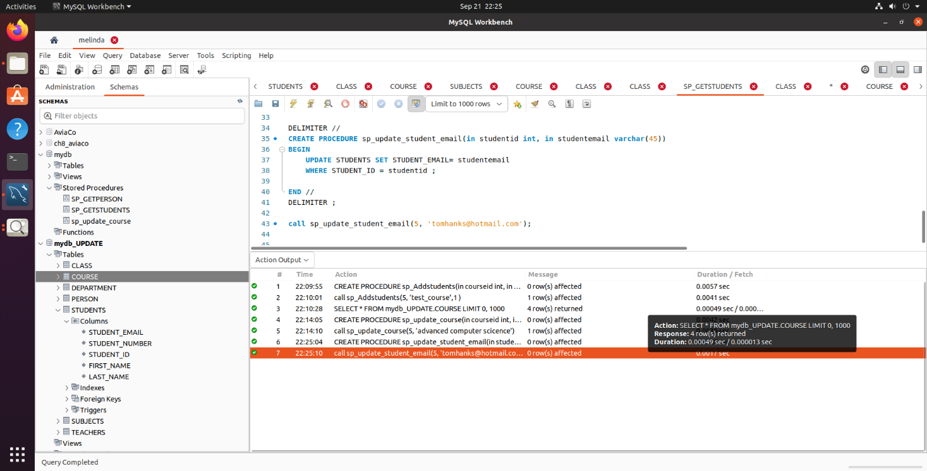

DELIMITER //

CREATE PROCEDURE sp_update_student_email(in studentid int, in studentemail varchar(45))

BEGIN

UPDATE STUDENTS SET STUDENT_EMAIL= studentemail

WHERE STUDENT_ID = studentid ;

END //

DELIMITER ;

call sp_update_student_email(5, 'tomhanks@hotmail.com');

## Dropping a Stored Procedure

DROP PROCEDURE SP_GETSTUDENTS

# Triggers

## Trigger 1

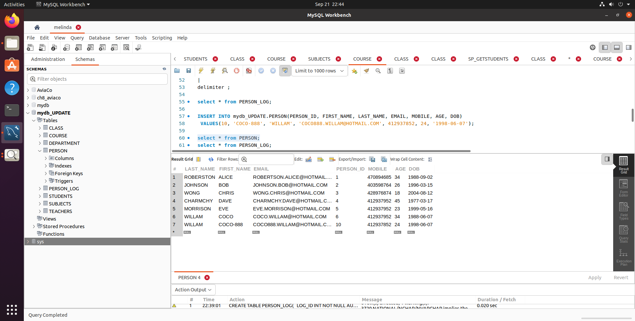

## Trigger 2

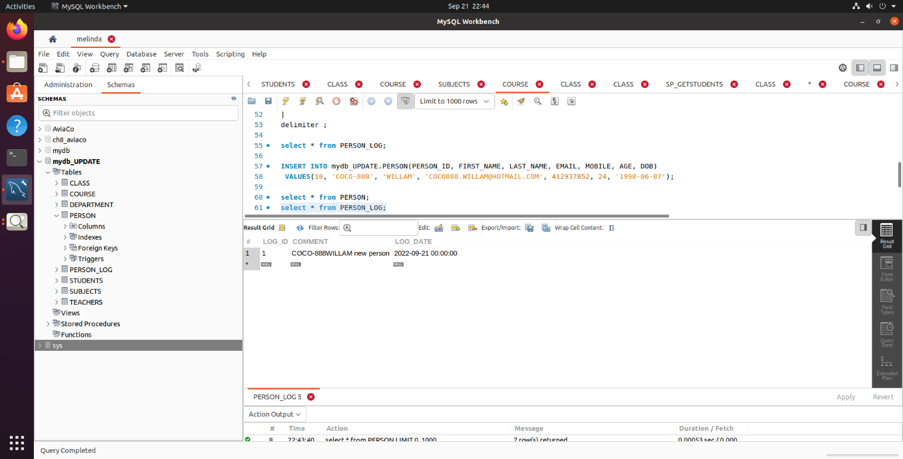

CREATE TABLE PERSON_LOG(

LOG_ID INT NOT NULL AUTO_INCREMENT,

COMMENT nvarchar(500) NOT NULL,

LOG_DATE datetime NOT NULL ,

primary key(LOG_ID)

);

delimiter |

CREATE TRIGGER TRIG_PERSON_LOG

AFTER INSERT ON PERSON

FOR EACH ROW

BEGIN

INSERT INTO PERSON_LOG

(COMMENT,LOG_DATE)

VALUES

(concat(NEW.FIRST_NAME, '', NEW.LAST_NAME, ' new person'), curdate());

END;

|

delimiter ;

select * from PERSON_LOG;

INSERT INTO mydb_UPDATE.PERSON(PERSON_ID, FIRST_NAME, LAST_NAME, EMAIL, MOBILE, AGE, DOB)

VALUES(10, 'COCO-888', 'WILLAM', 'COCO888.WILLAM@HOTMAIL.COM', 412937852, 24, '1998-06-07');

select * from PERSON;

select * from PERSON_LOG;

my explanation about my trigger:

1. specify the name of the trigger is TRIG_PERSON_LOG
2. specify the trigger action time is AFTER, which indicates that the trigger is invoked after each row is modified.
3. The operation of activating the trigger is INSERT.
4. The name of table to which the trigger belongs PERSON
5. When the trigger invokes, the statement will be executed: insert a record including ‘COMMENT’ and ‘LOG_DATE’ into table PERSON_LOG

# Appendix